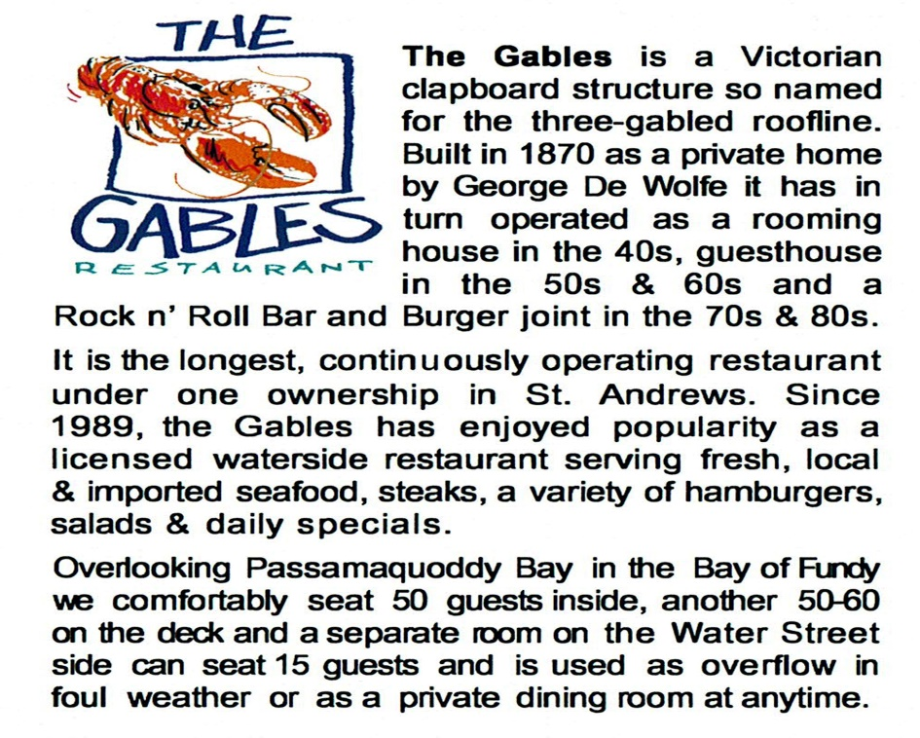
NOW HIRING!
Line Cook
Duties: can cook steaks, burgers and help out in all aspects of the kitchen under the guidance of the head chef. Preparing in the slow times for the busy times. Cleaning and sanitizing. Some kitchen experience is required. Wages are competitive plus gratuities and bonuses.

Prep Cook
Duties: making salads, sandwiches and prepping all ingredients for salads and sandwiches in the slow times to prepare for the busy times. Cleaning and sanitizing. Experience is an asset but will train the right candidate. Wages are competitive plus gratuities and bonuses.

Fry Cook
Duties: cooking with seafood and fries in a deep fryer. Making batter for seafood, packaging ingredients to deep fry. Cleaning and Sanitizing. Experience is an asset, but not necessary, we will train the right candidate. Wages are competitive plus gratuities and bonuses.

Dishwasher
Duties: clearing tables, transporting dirty dishes to kitchen and loading and unloading the dishwasher and putting away the cleaned dishes. Experience is not required will train the right candidate. Wages are competitive plus gratuities and bonuses.

Food and Beverage Server
Duties: greeting customers, explaining specials and menu, taking orders, using a pos system, making and serving beverages, serving the orders to the customers with a smile. Must be 19 years of age or older. Experience is an asset but not a requirement. Wages are competitive plus gratuities and bonuses.

APPLY TODAY! Submit your resume to: thegablesmanager@gmail.com

