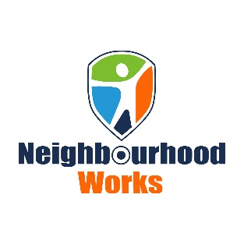

Now Hiring! Youth Worker in St. Stephen, New Brunswick
POSITION AVAILABLE IMMEDIATELY
We are seeking a highly motivated individual that is passionate about working with youth for a
non-profit residential facility for at-risk youth in St. Stephen.
Must be a team player, a positive role model with strong leadership abilities and be able to
mentor others.
Qualifications:
Bachelor’s Degree in a related field or two-year Youth Care Worker Diploma including trauma-
based care.
Human Services Certificate.
Experience working in a youth residential facility would be a strong asset.
Must have excellent verbal and written communication skills and a clean drivers abstract.
We offer competitive wages and benefits.
Full-time and part-time hours available.
Salary: $20.61 per hour
To apply, please forward your resume to jim.stuart@neighbourhoodworks.org, or contact:
James A Stuart, Executive Director
Neighbourhood Works Inc.
jim.stuart@neighbourhoodworks.org
(506)466-0100

